Project Design Phase-II
Technology Stack (Architecture & Stack)

Date | 07 March 2026
Team ID | PNT2022TMID00001
Project Name | Predictive Pulse
Maximum Marks | 4 Marks

Technical Architecture:

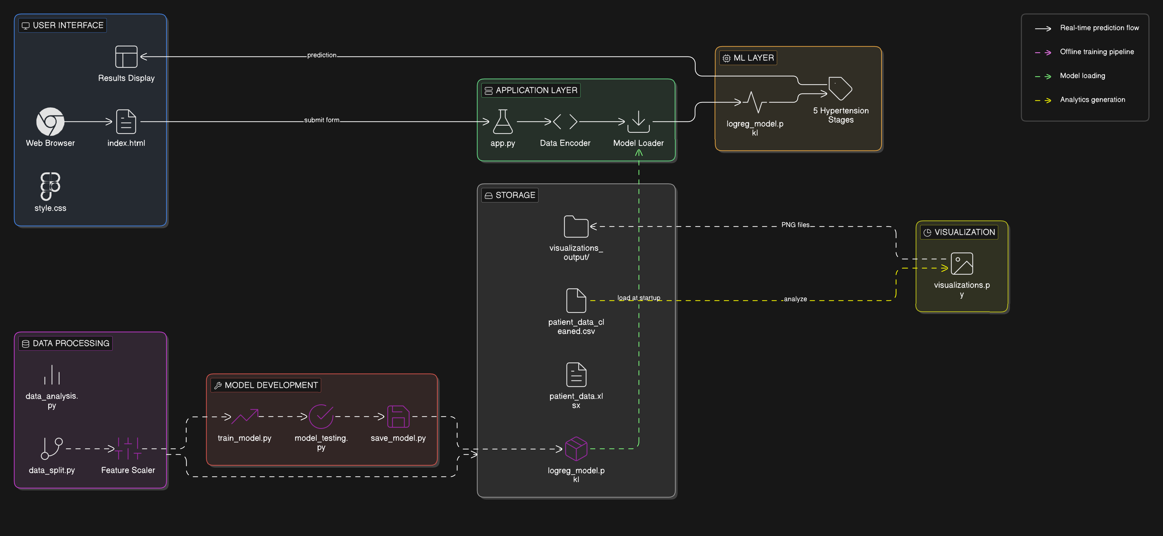

Table-1 : Components & Technologies:

S.No | Component | Description | Technology
1 | Web Interface | User-facing form for entering patient data and viewing prediction result | HTML5, CSS3
2 | Flask Web Server | Handles HTTP requests, routing, and returning responses | Flask (Python)
3 | Prediction Endpoint | POST API that receives input data and returns hypertension stage | Flask REST API
4 | Data Encoding Module | Converts categorical inputs (Gender, Age group, Yes/No) to numeric form | Python (NumPy)
5 | Logistic Regression Model | ML model that predicts hypertension stage using 12 features | Scikit-learn
6 | Model Loader | Loads trained model for real-time prediction | Joblib
7 | Data Cleaning Module | Removes duplicates, handles null values, standardizes columns | Pandas, NumPy
8 | Label Encoding System | Converts categorical features into numerical labels | Scikit-learn LabelEncoder
9 | Data Splitting Module | Splits dataset into training (80%) and testing (20%) | Scikit-learn train_test_split
10 | Feature Scaler | Standardizes features (zero mean, unit variance) | Scikit-learn StandardScaler
11 | Model Training Pipeline | Trains multiple ML algorithms and compares performance | Scikit-learn
12 | Model Evaluation System | Generates accuracy, classification report, and metrics | Scikit-learn metrics
13 | Visualization Generator | Produces charts for analysis and insights | Matplotlib, Seaborn
14 | Raw Dataset Storage | Stores original patient dataset | Excel (.xlsx)
15 | Cleaned Dataset Storage | Stores processed dataset after preprocessing | CSV
16 | Model Persistence Storage | Saves trained model file | Joblib (.pkl)
17 | Visualization Storage | Stores generated graphs | PNG
18 | CSS Styling | Provides design and responsive UI | CSS3
19 | Alternative ML Models | Random Forest, Decision Tree, SVM, KNN, Naive Bayes, Ridge | Scikit-learn
20 | Jupyter Notebook | Environment for development and experimentation | Jupyter Notebook (.ipynb)

Table-2: Application Characteristics:
S.No | Characteristics | Description | Technology
1 | Multi-Class Classification | Predicts 5 hypertension stages (Normal, Elevated, Stage-1, Stage-2, Hypertensive Crisis) using patient health features | Logistic Regression, Scikit-learn
2 | Real-Time Web Prediction | Instant hypertension risk prediction via web form with 12 input parameters | Flask REST API, HTML5, CSS3
3 | Comprehensive Data Preprocessing | Automated cleaning, label encoding, feature scaling, and stratified 80-20 train-test split | Pandas, NumPy, StandardScaler
4 | Visual Analytics Dashboard | Generates statistical charts like correlation heatmap, distribution plots, and stage analysis | Matplotlib, Seaborn

References:
https://myskillwallet.ai/dashboard/skillwallet/module/Artificial-Intelligence-%26-Machine-Learning---vishwakarmacollege-698c2da7af9e32369b90c334/group-projects/697deb2deb13fbba7f9fccee/Predictive-Pulse:-Harnessing-Machine-Learning-for-Blood-Pressure-Analysis-699d5f82fdf409fdbd1bec75
https://www.futureskillsprime.in/journey/daf-stem/
https://learning.servicenow.com/now/lxp/home
IBM – Study Material And Sources

